# CS 255 System Design Document Template

## UML Diagrams

### UML Use Case Diagram

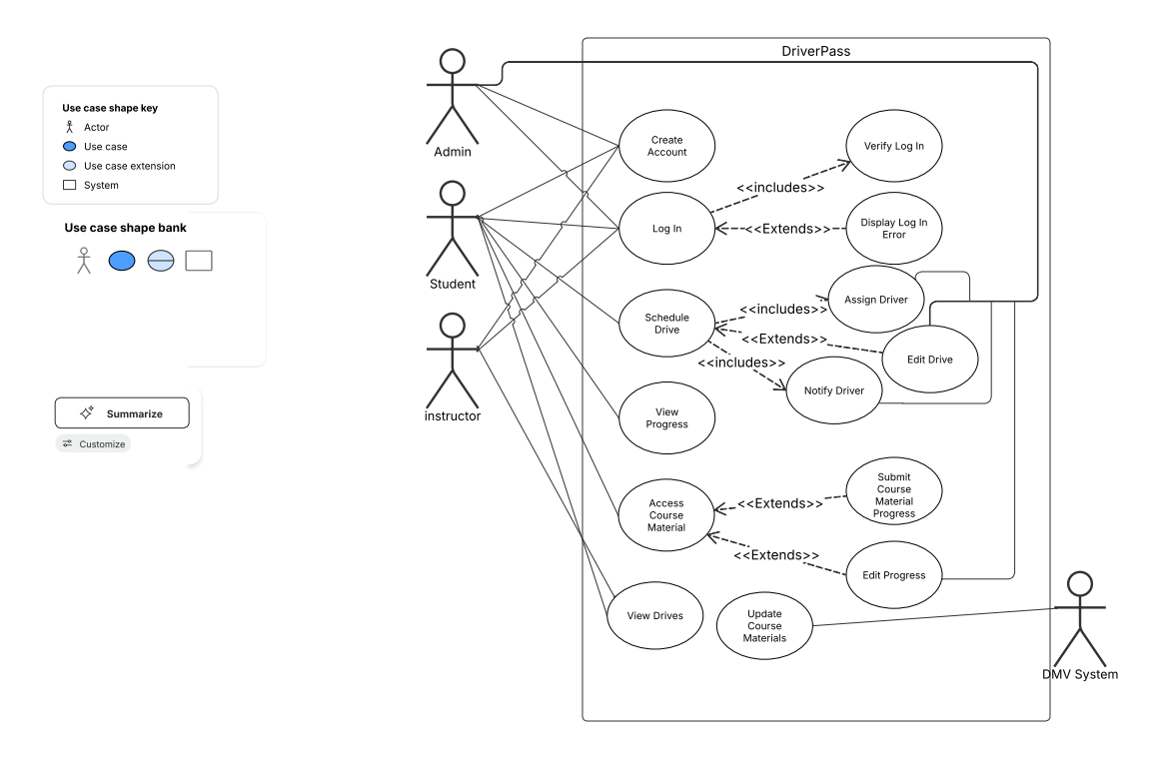

### UML Activity Diagrams

Use Case: Login

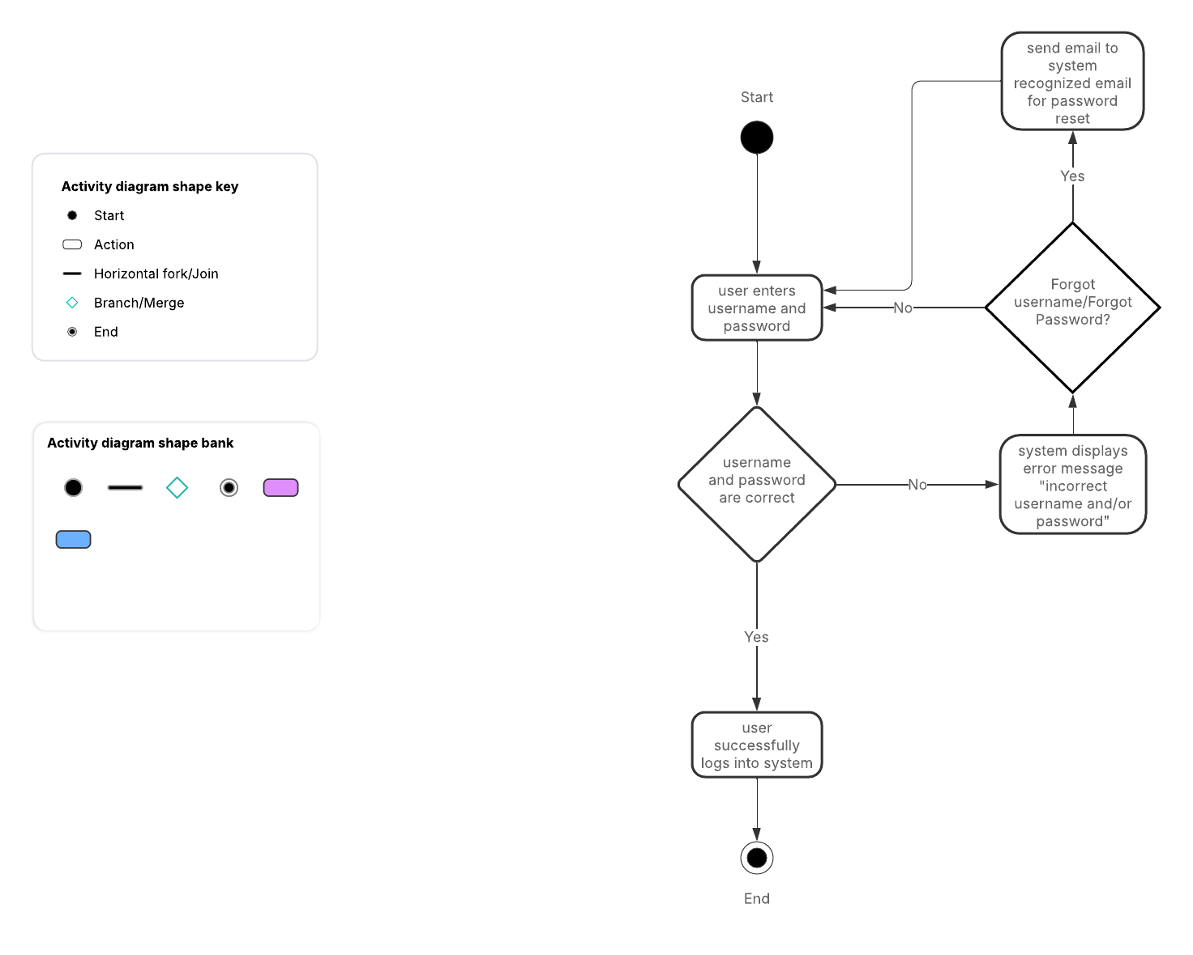

Use Case: Schedule Drive (for Student)

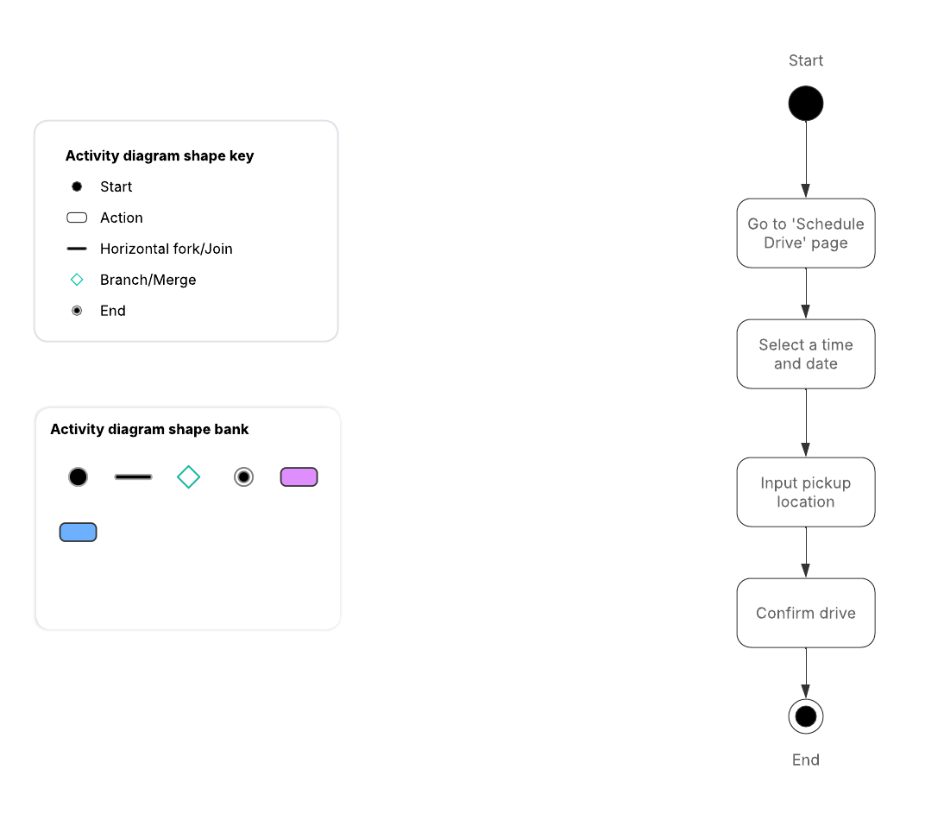

### UML Sequence Diagram

Use Case: Login

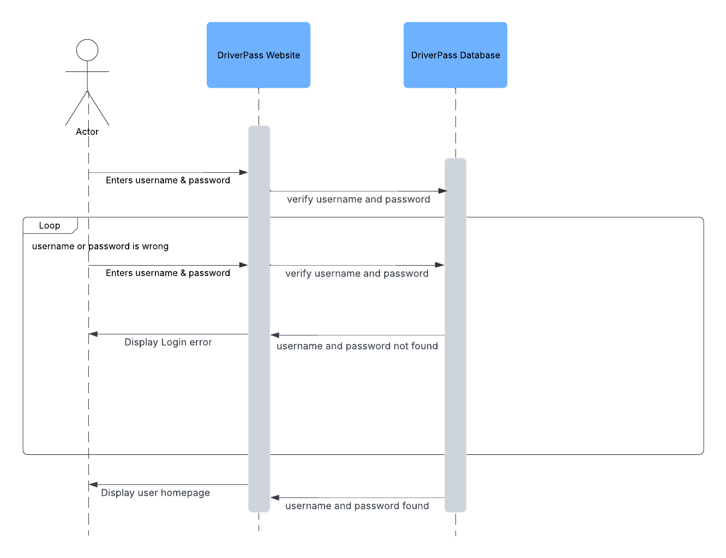

### UML Class Diagram

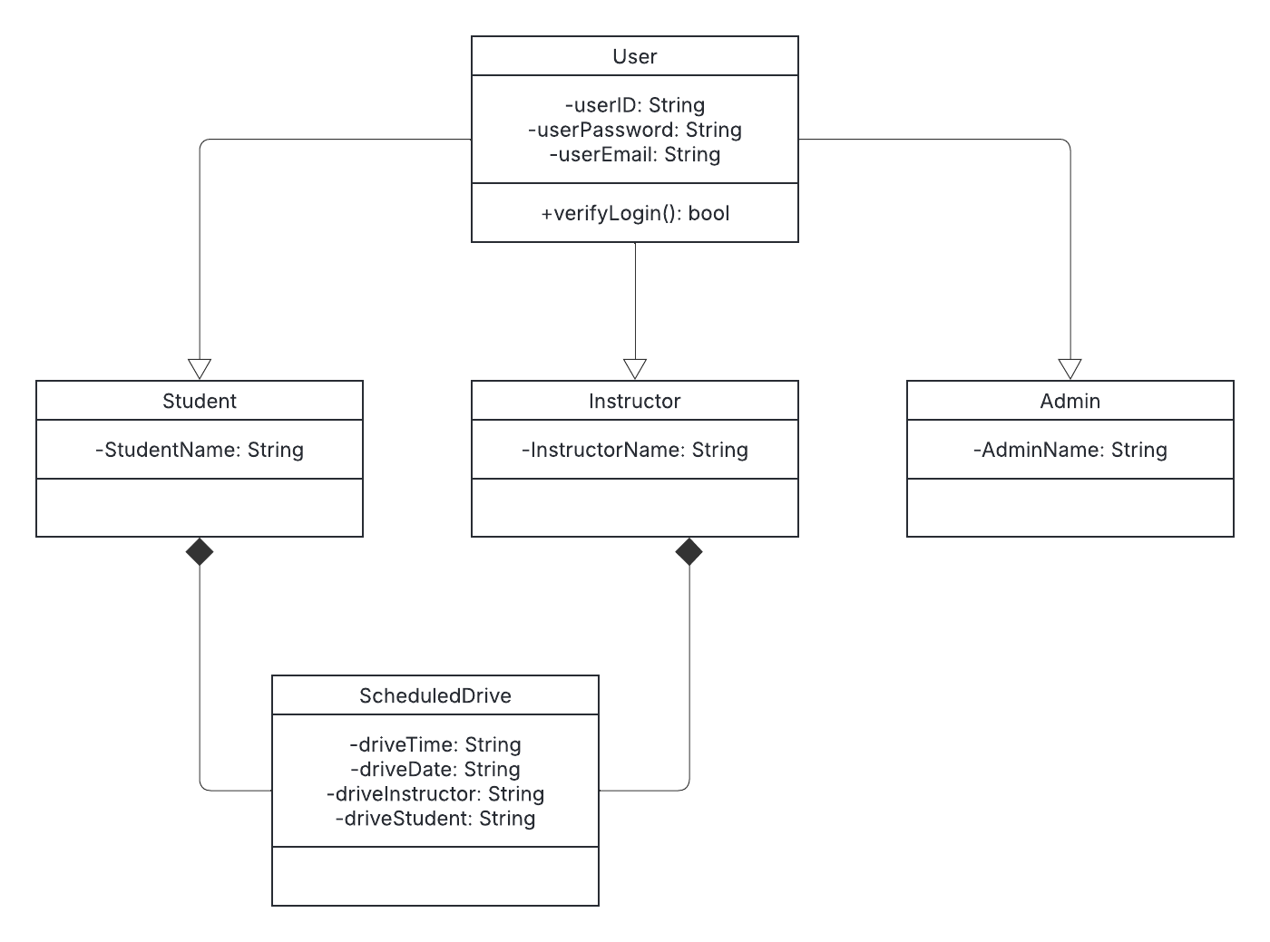

## Technical Requirements

Based on the diagrams, the technical requirements of the system include:

* server
* internet connection
* storage drives
* web server
* database server
* backup application for website and database